The Cypress team has developed 4 sample QRDA Cat III files for CMS32v4, CMS146v3, CMS153v3 and CMS156v3. These sample files can be found in the SITE QRDA Repository (<https://github.com/chb/sample_qrdas/ProjectCypress>). These 4 files can be used as representative QRDA Cat III files for all eCQMs (with respect to their structural elements). These samples include the structures necessary for Continuous Variable measures, Proportional measures, Multiple Stratification measures, Multiple Numerator/Denominator measures, Eligible Professional measures and Eligible Hospital measures. Below is a listing of measures that each of these samples can represent. A graphical depiction of these 4 QRDA Cat III files is also provided below.

**CMS32v4** can be used as a model for Continuous Variable measures. These measures include: CMS111v3, and CMS179v3.

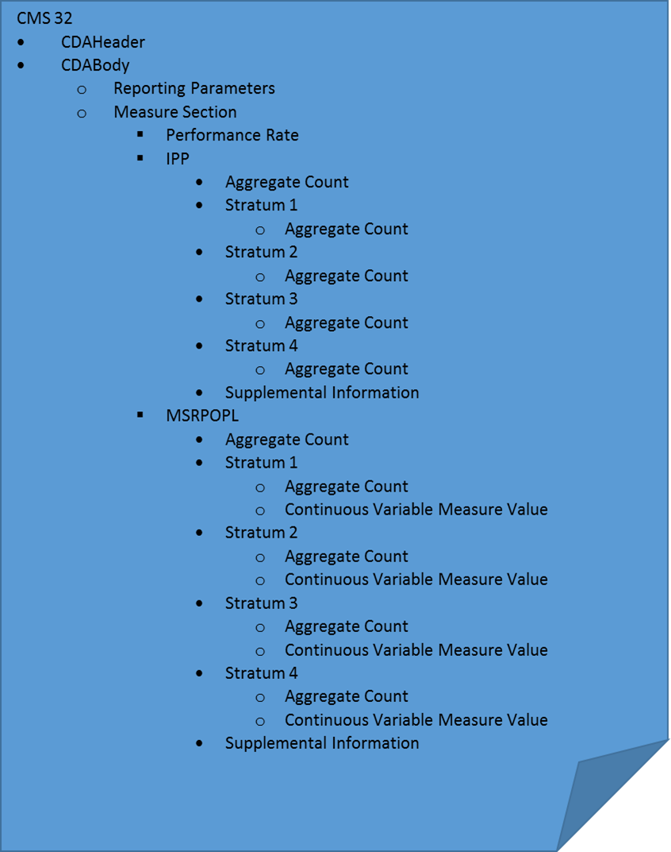**CMS32v4** can be also used as a model for Continuous Variable measures with multiple Stratifications. These measures include: CMS55v3.

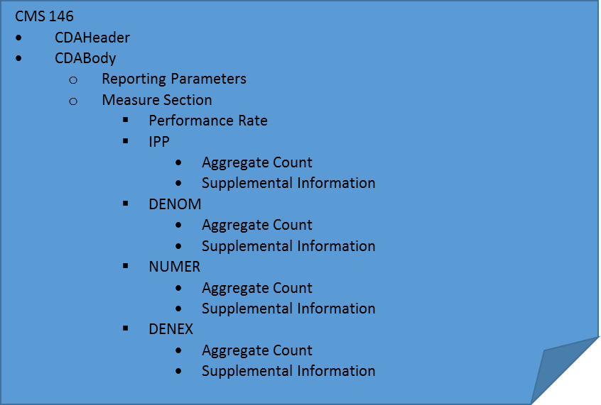**CMS146v3** can be used as a model for Proportional measures. These measures include: CMS2v4, CMS22v3, CMS26v2, CMS30v4, CMS31v3, CMS50v3, CMS53v3, CMS56v3, CMS62v3, CMS65v4, CMS66v3, CMS68v4, CMS71v4, CMS72v3, CMS73v3, CMS75v3, CMS77v3, CMS82v2, CMS90v4, CMS91v4, CMS100v3, CMS102v3, CMS104v3, CMS105v3, CMS107v3, CMS108v3, CMS109v3, CMS110v3, CMS113v3, CMS114v3, CMS117v3, CMS122v3, CMS123v3, CMS124v3, CMS125v3, CMS127v3, CMS129v4, CMS130v3, CMS131v3, CMS132v3, CMS133v3, CMS134v3, CMS135v3, CMS138v3, CMS139v3, CMS140v3, CMS141v4, CMS142v3, CMS143v3, CMS144v3, CMS147v4, CMS148v3, CMS149v3, CMS154v3, CMS157v3, CMS158v3, CMS159v3, CMS161v3, CMS163v3, CMS164v3, CMS165v3, CMS166v4, CMS167v3, CMS169v3, CMS177v3, CMS178v4, CMS185v3, and CMS190v3.

**CMS153v3** can be used as a model for Multiple Stratification measures. These measures include: CMS74v4, CMS126v3, and CMS137v3.

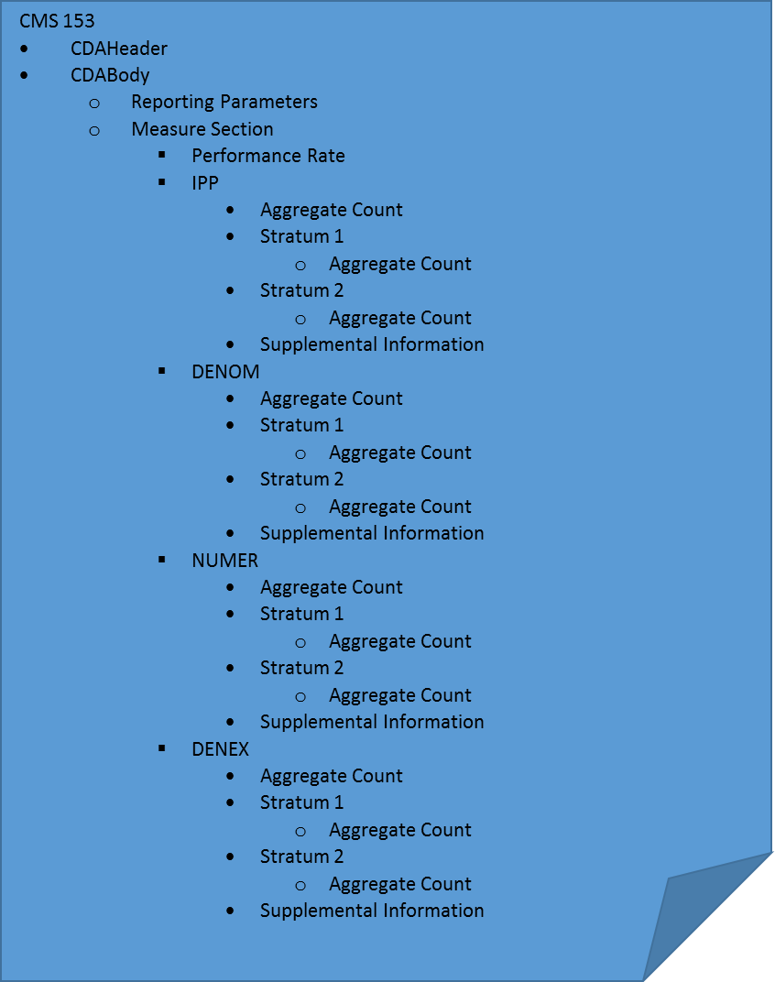

**CMS156v3** can be used as a model for Multiple Numerator/Denominator measures. These measures include: CMS9v3, CMS52v3, CMS61v4, CMS64v4, CMS69v3, CMS128v3, CMS136v4, CMS145v3, CMS160v3, CMS171v4, CMS172v4, CMS182v4, and CMS188v4.

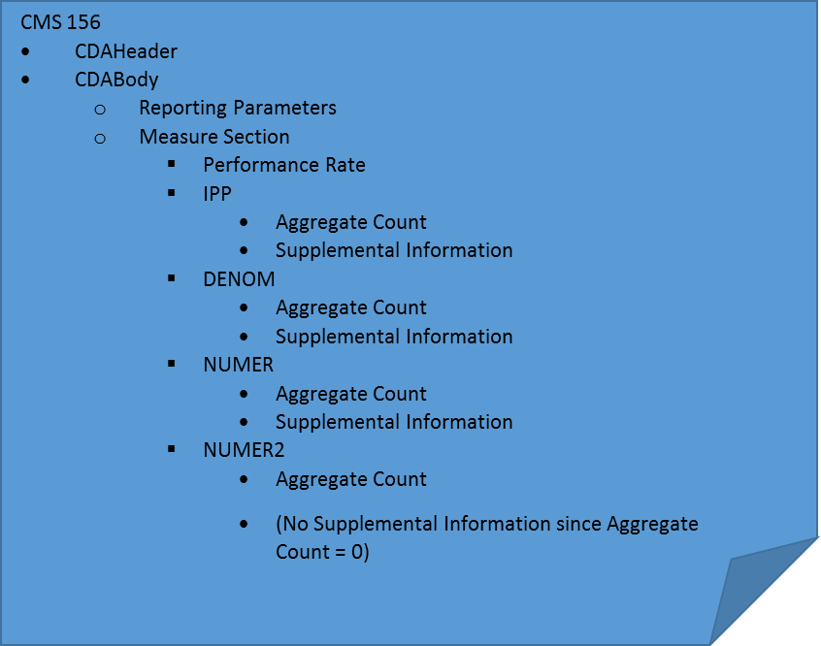

**CMS153v3** and **CMS156v3** can be used (in combination) as models for measures with multiple Stratifications and multiple Numerators. These measures include: CMS155v3.